WALGA Corporate Adaptation Action Plan
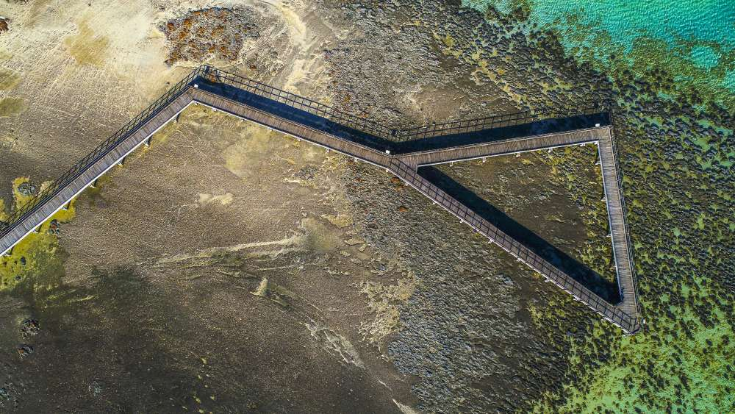
Image: Stromatolites, Shark Bay (Source: WALGA)

Image: Greens Pool, Denmark (Source: WALGA)
Acknowledgement
The WA Local Government Association (WALGA) acknowledges the Traditional Owners of the land and pays respects to Elders past, present and emerging.

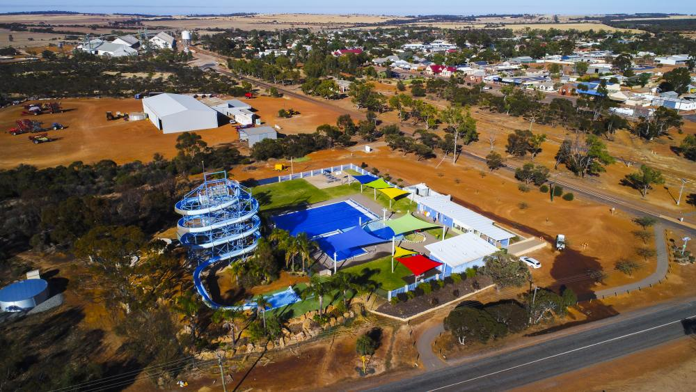
Image: Kulin (Source: WALGA)
Image: Nungarin Sports Complex (Source: WALGA)

Table of Contents

Using this Corporate Adaptation Action Plan template 1
Acknowledgement of Country 6
Executive Summary 7
Purpose of this document 7
Context 8
Climate science 8
Climate scenarios 8
Projected climatic changes 10
Role of Government 11
Adaptation and Mitigation 13
Approach to Climate Change 15
Stakeholder Engagement 18
Climate Risk Assessment Process 19
Risks and Opportunities 24
Evaluation and Prioritisation of Adaptation Actions 26
Actions 29
Communication 34
Monitoring and Evaluation 35
Reporting 38
Glossary 40

Image: Nungarin Sports Complex (Source: WALGA)

Using this Corporate Adaptation Action Plan template
This Corporate Adaptation Action Plan template has been developed to assist Local Government to establish corporate adaptation actions that improve the resilience of their operations to the impacts of climate change.
The template contains text in red that is intended to be edited by Local Governments to reflect their climate adaptation actions and commitments.
A Corporate Adaptation Action Plan may be developed as a third step by a Local Government following the development of a Climate Change Policy and Climate Change Declaration and/or Climate Emergency Declaration.
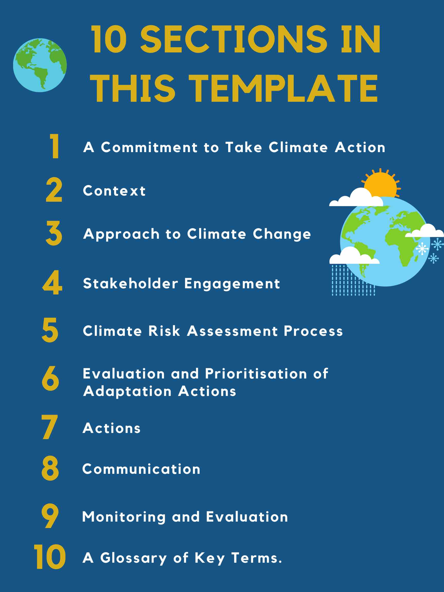
The actions outlined in the Corporate Adaptation Action Plan should align with the commitments that have been endorsed by the Councils as part of the Local Government’s Climate Change Declaration and/or Climate Emergency Declaration.
In contrast to the Corporate Mitigation Action Plan, the Corporate Adaptation Action Plan specifically focuses on identifying actions that the Local Government can take to manage the risks, and adapt to the impacts of climate change on their operations.
There are 10 sections in this template with descriptions of each section and requirements summarised below.

- A Commitment to Take Climate Action
The first section provides an executive summary and includes a high level statement that requires an acknowledgement by the Local Government that:
- Action needs to be taken now to manage the impacts of climate change; and
- Demonstrates a commitment to climate action through relevant Local Government climate plans.
The purpose of the Corporate Adaptation Action Plan is also outlined in this section.
- Context
The second section provides background information on the climate science, including climate scenarios, and requires the Local Government to list projected changes to their local climate. Information on the role of Local Government in supporting communities to adapt to climate change and a comparison of adaptation and mitigation actions is also provided.
- Approach to Climate Change
In this section the Local Government is required to list the commitments made through their Climate Change Declaration and/or Climate Emergency Declaration and actions already taken to address climate change. If the Local Government has not yet formalised their approach to climate change or has not yet conducted any climate change planning this section can be excluded from their Action Plan/s.
- Stakeholder Engagement
The fourth section requires the Local Government to list the stakeholder engagement activities they plan to undertake to engage their communities as part of the implementation of their climate change action planning.
- Climate Risk Assessment Process
The fifth section provides guidelines for the Local Government to undertake a climate risk assessment to inform the selection of climate change adaptation actions. The Local Government is then required to detail the key steps taken as part of the Local Governments risk assessment process and provide a list of the risks that were identified.
- Evaluation and Prioritisation of Adaptation Actions
In this section example criteria are provided to support the Local Government to evaluate, prioritise and select corporate adaptation actions that are realistic and will be the most effective in building the resilience of Local Government operations. The Local Government is then required to list the criteria they used to assess and prioritise their corporate climate adaptation actions. It is recommended that the Local Government assesses each of the action areas they have selected/included in the WALGA Action Planning Excel Tool against the selected criteria, giving each a rating of low, medium or high.
- Actions
In this section, the Local Government is required to populate the provided table with corporate adaptation related actions from the action areas listed in the WALGA Action Planning Excel Tool. As a first step, the Local Government should select actions areas from the WALGA Action Planning Excel Tool, and adjust the wording and convert the action area into an action to reflect their current state and level of commitment. Following this, the Local Government should complete the ‘Results of evaluation and prioritisation process’ column, to indicate which action areas that have been chosen to progress. For each of the action areas that the Local Government has selected to progress, the Local Government should consider its current state with regards to the implementation of the action area and select from the drop down list in the ‘Current Status column.’
- Communication
The eighth section requires the Local Government to list the internal and external communication methods that will be adopted to ensure that the desired audience is reached, and obtain their support for climate change adaptation planning. This section is optional.
- Monitoring and Evaluation
In this section information is provided to support the Local Government to establish a monitoring and evaluation framework. The framework is used by the Local Government to assess the outcomes and effectiveness of the actions in their Corporate Adaptation Action Plan. This section also provides information on developing indicators for the monitoring and evaluation framework and requires the Local Government to commit to regular monitoring, a review of the Action Plan, and reporting.
- Glossary
In this final section a glossary is provided to define key terms used in this Community Adaptation Action Plan template

The Corporate Mitigation Action Plan template begins on the next page.

Local Governments may choose to edit or delete previous pages including:
- WALGA Corporate Mitigation Action Plan Template cover page
- WALGA Acknowledgement of Country
- Using this Corporate Mitigation Action Plan template instructions

Local Governments may also choose to remove WALGA’s header and footer and insert their own logo and templates.

Image: Treetop Walk, Walpole (Source: WALGA)

Shire/City/Town of [insert]

Corporate Adaptation Action Plan
Image: Elephant Rocks, Denmark (Source: WALGA)

Acknowledgement of Country
The Shire/City/Town of [insert] acknowledges the Traditional Owners and custodians of the insert Local Government area land, the insert name of Traditional Owners, and we pay our respects to their Elders past, present and emerging.

Executive Summary
The impacts of climate change are already being felt by communities around the world, including increasing temperatures, longer droughts, more frequent and intensive natural disasters such as heatwaves and bushfires, and sea level rise, and associated increases in coastal erosion and inundation. With these impacts projected to further increase over the coming years and decades, our Shire/City/Town needs to take action now to safeguard our future.
The risks associated with climate change are becoming more important to Local Governments, and the need for Local Governments to respond to, and manage the impacts of climate change has never been greater. With Local Governments on the front line of addressing climate change we have an important role to play. To establish our support for climate change action we have signed a Climate Change Declaration and/or Climate Emergency Declaration.
As outlined in our Climate Change Declaration we recognise that climate change will continue to have a significant effect on the Western Australian environment, society and economy. We have committed to addressing climate change within our Local Government area to minimise these impacts through [insert key commitments from Climate Change Declaration here].
The Shire/City/Town of [insert] acknowledges the importance of taking action, and as such is committed to finding practical ways to address climate change risks and impacts within our Shire/City/Town. We have developed a Climate Change Mitigation/Adaption/Community/Corporate Action Plan/s [insert other work here e.g. climate risk assessment] which brings together the adaptation/mitigation targets [Note: targets are optional] and actions that we will undertake in order to tackle climate change, build resilience and minimise the vulnerability of our area.
Our overall objective/s is to [insert climate change related objectives for the Local Government. These may include aligning to the Paris Agreement, demonstrating climate leadership, reducing corporate/community emissions, building the resilience of the Shire/City/Town to climate change etc.].
Acting on and responding to climate change is an ongoing process, and this/these Action Plan/s will be reviewed and updated regularly to reflect changing circumstances and emerging information.

Purpose of this document
The purpose of this document is to establish corporate adaptation actions for our Shire/City/Town. Through the implementation of these actions we can improve the resilience of our operations to climate change.

Context

Climate science
International scientific consensus is that climate change is occurring, and it is driven by anthropogenic (human) causes, with human activities having a profound impact on the concentration of greenhouse gas emissions since the start of the industrial revolution. Ultimately, these activities, such as the burning of fossil fuels, land clearing and agriculture, have increased greenhouse gas concentrations in the atmosphere, leading to changes in the climate system over long periods of time.
The Intergovernmental Panel on Climate Change (IPCC) is an international body responsible for assessing the science related to climate change. IPCC assessments provide a scientific basis for governments at all levels to develop climate related policies, and they are fundamental inputs to negotiations at the United Nations Climate Conferences and the negotiation of international climate agreements. The IPCCs latest report, the Fifth Assessment Report, found that:
“Warming of the climate system is unequivocal, and since the 1950s, many of the observed changes are unprecedented over decades to millennia. The atmosphere and ocean have warmed, the amounts of snow and ice have diminished, sea level has risen, and the concentrations of greenhouse gases have increased.
Most aspects of climate change will persist for many centuries even if emissions of CO₂ are stopped.”
The IPCC has also found:
“It is extremely likely [95–100%] that human influence has been the dominant cause of the observed warming since the mid-20th century.”

Climate scenarios
In order to make projections of future climate change, the scientific community develop climate models, using advanced computer simulations, for a range of different greenhouse gas emissions scenarios (i.e. projections of what the global greenhouse emissions may be in future years). These scenarios are used to inform policy and decision makers to plan for the future.
In the Fifth IPCC Assessment, a set of four possible scenarios, also known as Representative Concentration Pathways (RCPs), were proposed. These RCPs represent possible pathways based on global atmospheric greenhouse gas emissions concentrations and predict how concentrations of greenhouse gases in the atmosphere will impact the climate.
- Very low emissions scenario – based on the IPCC’s RCP2.6. Under this scenario, significant collaborative effort will be made to drive decarbonisation and lower emissions, which will result in a temperature increase of 1ºC, a 0.4m sea level rise and a minor increase in extreme weather events (by 2081-2100, relative to 1986-2005).

- Low emissions scenario – based on the IPCC’s RCP4.5. Under this scenario, collaborative efforts will be made to drive decarbonisation and lower emissions, which will result in a temperature increase of 1.8ºC, a 0.47m sea level rise and a moderate increase in extreme weather events (by 2081-2100, relative to 1986-2005).

- High emissions scenario – based on the IPCC’s RCP6.0. Under this scenario, minimal efforts will be made to drive decarbonisation and lower emissions, which will result in a temperature increase of 2.2ºC, a 0.48m sea level rise and a moderate increase in extreme weather events (by 2081-2100, relative to 1986-2005).

- Very high emissions scenario – based on the IPCC’s RCP8.5. Under this scenario, very low efforts will be made to drive decarbonisation and lower emissions, which will result in a temperature increase of 3.7ºC, a 0.63m sea level rise and a large increase in extreme weather events (by 2081-2100, relative to 1986-2005).

Projected climatic changes
Guidelines
The following Local Government specific impacts are examples only and each Local Government should refer to established sources of climate change information when completing this section to obtain up to date information on the projected impacts to their area.
This may include CoastAdapt’s Sea-level rise and You tool, which can assist in understanding the impacts of climate change on sea level rise, inundation, temperature and rainfall in each Local Government area. The Bureau of Meteorology’s State of the Climate Report is published annually, and also includes details on specific climatic changes across Australia, which Local Governments can refer to when developing local impact lists. Another useful source of information is the Climate Change in Australia website, which provides projections and data for Australian regions, as well as other climate change related resources.
In addition, Local Governments should refer to relevant state government policies, such as State Planning Policy 2.6, which outlines sea level change projections based on future emissions scenarios, which can be used for coastal planning.
In the 20th century the impacts of climate change have become increasingly visible, with observed impacts including increases in global average air and ocean temperatures, rising global sea level, long-term sustained widespread reduction of snow and ice cover, and changes in atmospheric and ocean circulation and regional weather patterns, which influence seasonal rainfall conditions.
These changes threaten both human and natural systems, both directly and also through increased extreme weather events, such as heat waves, cyclones and other natural disasters, coastal inundation due to sea level rise, and disruptions to rainfall patterns.
In Australia, the 2018 Bureau of Meteorology State of the Climate Report (CSIRO and Australian Government Bureau of Meteorology 2018) noted that Australia has experienced increases to sea and air temperatures, sea level rises and ocean acidification, along with observed declines in rainfall amounts in the southwest and southeast of Australia.
Australia is the driest inhabited continent on earth, and even in the absence on climate change is characterised by variability and extremes. With the impacts of climate change projected to place additional stress on our natural and human systems, there is an urgent need to address climate change.
For the Shire/City/Town of [insert] projected changes to our climate in the future include:
[Only include relevant climate changes to the Local Government area from the list below, note that not all items must be included and that only those applicable to the region are recommended to be included]
- Further increase in temperatures, with more extremely hot days and fewer extremely cool days;
- More heat waves that will be longer and hotter;
- More frequent, extensive, intensive and longer‐lasting marine heatwaves;
- Ongoing sea level rise;
- Further warming and acidification of the oceans;
- A decrease in cool‐season rainfall across southern Australia, including the southwest of WA;
- Likely increase in wet season rainfall in the north of WA;
- More frequent, longer and more intense droughts across southern Australia, including the southwest of WA;
- More intense heavy rainfall throughout Australia, particularly for short‐duration extreme rainfall events (storms);
- An increase in the number of high fire weather danger days and a longer fire season for southern and eastern Australia;
- Fewer tropical cyclones, but a greater proportion of high‐intensity storms, with large variations from year to year; and
- Through a combination of many of these impacts, changes to biodiversity including increased species extinction.
These changes will have impacts on our environment, our infrastructure and assets, and our communities.

Role of Government
As a signatory to the Paris Agreement under the United Nations Framework Convention on Climate Change and the United Nations Sustainable Development Goals (SDGs), Australia has committed to taking action on climate change and to ensuring that mitigation and adaptation action is equitable and consistent with the aims of the SDGs. The Paris Agreement expressly recognises the importance of engagement at all levels of government. As such, the management of climate-change risks is spread across the three tiers of government: Commonwealth, State and Territory and Local.
In 2012, the Councils of Australian Governments (COAG) formally agreed on the roles and responsibilities for climate-change adaptation in Australia.
The Commonwealth Government is responsible for:
- Managing climate change science and national adaptation research to allow Australia to effectively adapt to the impacts of climate change;
- Providing leadership on national adaptation reform, and collaborating with States and Territories in setting and implementing national priorities and regional priorities;
- Managing climate change risks and impacts across the Commonwealth’s portfolio of assets and programs; and
- Maintaining a strong, flexible economy and social safety net that will help Australia adapt to climate change impacts by ensuring resources are available to respond to climate change and can be deployed efficiently.

The State and Territory Governments are responsible for:

- Providing local and regional science and information;
- Managing climate change risks and impacts across State and Territory assets and programs;
- Working with the Commonwealth to implement the national adaptation reform; and
- Encouraging climate resilience and adaptive capacity.
Local Governments are on the frontline in addressing climate change impacts and have a critical role to play in ensuring that mitigation and adaptation responses are suitably tailored to the specific risks in our area, and that our local communities and stakeholders are consulted and involved in our efforts. We have the capacity to implement planning and development measures that reduce the impacts of climate change on all aspects of the community, and therefore have more hands-on responsibilities than the Commonwealth Government and complementary responsibilities to State and Territory governments.
Local Governments are responsible for:
- Administering relevant state and territory and/or Commonwealth legislation to promote adaptation as required including the application of relevant codes;
- Managing risks and impacts to public assets owned and managed by Local Governments;
- Managing risks and impacts to Local Government service delivery;
- Collaborating across Local Governments and with State and Territory Governments to manage risks of regional climate change impacts;
- Ensuring policies and regulations under their jurisdiction, including local planning and development regulations, incorporate climate change considerations and are consistent with State and Commonwealth Government adaptation approaches;
- Facilitating building resilience and adaptive capacity in the local community, including through providing information about relevant climate change risks;
- Working in partnership with the community, locally based and relevant NGOs, business and other key stakeholders to manage the risks and impacts associated with climate change; and
- Contributing appropriate resources to prepare, prevent, respond and recover from detrimental climatic impacts.

Adaptation and Mitigation
Guidelines
The purpose of this section is to provide clarity to the Local Government, and readers on the difference between adaptation and mitigation, to provide context for the actions that are included in the plan and how they fit in with overall climate change planning.
Please note that this section is for context only, and while it is recommended to be included, Local Governments may choose to exclude this section if it is deemed to not be required e.g. if these definitions are made clear in other documents.
The impacts of climate change will impact the Shire/City/Town of [insert] in a variety of ways. These impacts are predicted to increase in severity and frequency in the future, which will pose increasing risks to our community, environment, assets and infrastructure. In order to respond to these impacts there are two main categories of climate change response: adaptation and mitigation, both of which are essential, and equally as important in addressing climate change.
- Climate change mitigation involves actions that are intended to reduce our greenhouse gas emissions to minimise the severity of climate change or enhance the sinks for these emissions. For example, mitigation actions may include switching to renewable forms of energy such as wind and solar, and implementing energy efficiency initiatives, and supporting emission sinks such as investing revegetation and or modified landscape management (e.g. fire management) to improve carbon capture.

- Climate change adaptation consists of actions undertaken to reduce the consequences of the physical impacts of climate change, as well as to harness any opportunities as a result of these actions. Through adaptation actions we will become more prepared and able to adapt to the impacts of climate change, reducing our vulnerability. For example, adaptation actions may include building seawalls to protect infrastructure from erosion, raising the height of houses in flood prone areas, or behaviour change initiatives, such as monitoring vulnerable segments of the community during heatwaves.
Mitigation addresses reducing the causes of climate changes (greenhouse gas emissions), whereas adaptation addresses the impacts of climate change and associated risks and how we respond to them. For effective global mitigation it is important for everyone in the community, all businesses, and all levels of government to contribute to reducing emissions.Therefore, an effective climate change response requires both adaptation and mitigation actions to build the resilience of our Shire/City/Town to the impacts of climate change and help avoid worst case climate change scenarios.
This plan outlines Shire/City/Town of [insert]’s targets [Note: targets are optional] and relevant adaptation and/or mitigation actions that we have committed to at the community and/or corporate level/s.

Image: Cocos Islands (Source: WALGA)

Approach to Climate Change
Guidelines
Within this section Local Governments should document their approach to climate change. This section will need to be tailored by Local Governments to ensure it aligns with their approach, and Climate Change Declaration.
Local Governments should also describe any climate change related programs/actions completed to date in this section, including community engagement. Where a Local Government has completed substantial work to date it may consider including this information in a paragraph rather than a list.
If a Local Government does not yet have a formalised approach to climate change, or has not yet conducted climate change planning, this section can be excluded from the Action Plan/s.
In 2021 we signed our Climate Change Declaration/Climate Emergency Declaration. As part of this/these Declaration/s we have committed to [Note: update list to align with Climate Change Declaration/Climate Emergency Declaration]:
- Develop and implement a Climate Change Action Plan/Corporate and/or Community Adaptation Action Plan/ Corporate and/or Community Mitigation Action Plan.
- Set an appropriate emissions reduction target and work towards its achievement.
- Encourage and empower the local community and local businesses to reduce their greenhouse gas emissions and to adapt to the impacts of climate change.
- Support WALGA to work with State and Federal Government to ensure achievement of greenhouse gas emissions reduction targets as set out in key National and International agreements.
- Support WALGA to work with State and Federal Government to implement key actions and activities for climate change management at a local level.
- Work with key stakeholders within the Shire/City/Town/our community to ensure achievement of the actions set out in our Climate Change Action Plan/Corporate and/or Community Adaptation Action Plan/ Corporate and/or Community Mitigation Action Plan.
- Assess the locally specific risks associated with climate change and implications for our services, and identify areas where appropriate mitigation and/or adaptation strategies should be developed and implemented.
- Ensure that, at appropriate review intervals, our climate change Action Plans/policies/strategies are reviewed and amended to incorporate the latest climate science, and to reflect the climate change management priorities and progress achieved to date.
- Monitor the progress of our adaptation and/or mitigation actions and communicate our achievements to the Councils and Community.
In order to respond to the impacts of climate change, the Shire/City/Town of [insert] has already taken action by:
[Select from/add to the list below based on the existing strategies and/or work completed by the Shire/City/Town to respond to climate change]
- Joining the Climate Protection Program
- Developing an Emissions Reduction Plan
- Developing a Climate Change/Emissions Reduction/Sustainability Strategy
- Developing a Climate Change Action Plan/Corporate and/or Community Adaptation Action Plan/Corporate and/or Community Mitigation Action Plan
- Undertaking a climate change risk assessment
- Adopting a net zero emissions/emissions reduction/renewable energy target
- Setting waste, electricity, gas and fuel etc. targets
- Reducing emissions from electricity/fleet/street lighting etc. by X/XX%
We are committed to taking (further) action at the corporate and/or community level to mitigate against, and adapt to, climate change, and hence have developed our Action Plan/s.
[Note: the inclusion of principles and practices is optional. These lists are indicative only and should be updated to reflect the principles and practices adopted and used by the Local Government]
We use the following principles to assist our climate change action planning:
- Ambitious – Our goals and actions work towards an ambitious vision.
- Inclusive – We involve multiple departments, stakeholders and communities in planning and implementation.
- Fair – We seek solutions that equitably address the risks of climate change and share the costs and benefits of action across the Shire/City/Town.
- Comprehensive and integrated – We aim to coherently undertake actions across a range of sectors within the Shire/City/Town, as well as supporting broader regional initiatives and the realisation of priorities of higher levels of government when possible and appropriate.
- Relevant – Our actions seek to deliver local benefits and support local development priorities.
- Actionable – We propose cost-effective actions that can realistically be implemented.
- Evidence-based – Our action planning reflects scientific knowledge and local understanding, and uses assessments of vulnerability and emissions and other empirical inputs to inform decision-making.
- Transparent and verifiable – We follow an open decision-making process, and set actions that can be measured, reported, verified, and evaluated.
When developing our actions we also seek to adopt the following practices:
- Opportunity – Actions provide co-benefits to the Local Government’s broader objectives.
- Resourcing – We have the appropriate level of resourcing.
- Implementation – Actions are integrated into the Local Government’s existing activities.
- Flexibility and adaptability – Actions are adaptable and flexible.
- Evaluation and monitoring – Implementation of actions can be effectively evaluated and monitored.

Stakeholder Engagement
Guidelines
The level of stakeholder engagement is likely to vary between local governments and is likely to be dependent on resources available. Stakeholder engagement is an important component to the implementation of climate change action planning and some form of engagement should be considered. For example, for local governments with limited resources, engagement may be primarily through online methods such as social media posts. Involving stakeholder groups throughout the design and implementation process of the Action Plan/s means that they are more likely to support, facilitate and participate in the climate change actions.
Local governments should select relevant stakeholder activities from the list below. Noting that this is not an exhaustive list and that other activities may be added. These may include, for example, adding climate change elements to existing stakeholder engagement activities.
Stakeholder engagement ensures that the needs of all stakeholders, both internal and external, are considered in organisational goal setting and strategy development. As such, the Local Government believes that effective consultation is critical to the success of climate adaptation and mitigation. Therefore, in order to evaluate the effectiveness and understand the viability of the Local Government’s response to climate change, the Local Government engages with both internal and external stakeholders.
Obtaining stakeholder input and understanding stakeholder views on our climate change response will also help us to more effectively design and embed actions within our Shire/City/Town. We will also use stakeholder engagement as part of our monitoring process to assess the effectiveness of our action. We will conduct the following stakeholder engagement activities:
- Conduct a survey for our employees/residents and/or businesses every X years to gain insights on the perceptions of our climate change challenges, and our climate change mitigation and adaptation actions.
- Consult with elected members. Obtain execution and elected member sign off on our climate change plans.
- Establish a climate change working group with residents.
- Conduct community meetings/forums/workshops.
- Engage with other Local Governments within our region to share learnings and progress regional actions.
- Engage with WALGA and other organisations to remain informed, and to contribute to discussions on climate change management at the Local Government level.
- Obtain feedback from our community through social media and online feedback forms.
[Note: the following statement is optional] Through our community engagement we will seek to obtain input from a diverse group of residents, employees and businesses [insert names of other key stakeholder groups].

Climate Risk Assessment Process
Guidelines
Conducting a climate risk assessment is a core component of climate change planning, and should be used to determine which risks are most significant, so that these can be effectively managed. Particularly for climate adaptation planning, where the outputs of the risk assessment should be used to inform the actions that are undertaken to improve the local government’s resilience.
It is recommended that all local governments conduct a climate change risk assessment to some degree to inform the selection of climate change adaptation actions, and to improve the effectiveness of any investment in targeting key adaptation areas. It is, however, understood that not all local governments will be in a position to complete a detailed risk assessment.
This section of the Action Plan should be tailored to align with the level of risk assessment completed by the local government, which will be based on their maturity and resourcing. For example, a mature local government may take a quantitative approach using spatial data to conduct their risk assessment, whereas less mature local governments may complete a less detailed qualitative assessment, that can them become progressively more granular as time progresses.
This guideline outlines a high level methodology for completing a climate change risk assessment. Please note that local government may choose to adapt this process to best suit their needs, and to align with pre-existing risk assessment methodologies.
It is recommended that local governments refer to more detailed guidance on this process in the NSW Guide to Climate Change Risk Assessment, the Climate Risk Management Guideline for Queensland Local Government, or the Australian Government’s Climate Change Impacts & Risk Management A Guide for Business and Government. These documents provided detailed guidance on the risk assessment process which local governments can follow as they progress through this process.
Process
Risk assessments should be conducted in line with ISO 31000:2018 Risk Management Guidelines, the process for which is summarised in the template below.

Preparing for the risk assessment
To prepare for the risk assessment process local governments should:
- Gain agreement on the purpose of the assessment (including confirming executive or community support).
- Collate the data and information resources required to undertake the assessment (e.g. a stocktake of relevant activities completed to date).
- Identify the quality and number of resources required.
- Form the project team and develop a project schedule.
Establish the scope and elements of the assessment
Local governments should next define the scope and key elements of the risk assessment. Defining the scope of the assessment may involve identifying the relevant objectives to be considered and their alignment with broader organisational objectives, then exploring the key areas of the local government’s responsibility, assets, operations and services, to understand the demographic, socio-economic and environmental context in which it will achieve the objectives.
These following activities may be completed at this stage (Additional guidance on conducting each is provided within the Australian Government’s Climate Change Impacts & Risk Management A Guide for Business and Government):
- deﬁning the business or organisation to be assessed and the scope of the assessment
- clarifying explicitly the objectives of the organisation
- identifying the stakeholders and their objectives and concerns
- establishing success criteria against which risks to the organisation’s objectives can be evaluated
- developing key elements of the organisation (such as its major areas of responsibility) as a means of structuring the process
- determining relevant climate change scenarios for the assessment.

Identify, analyse and evaluate risks
During this stage local governments will describe and list how climate changes will impact on each of the key elements of the local government, and then identify the risks that these will present to the local government. It is important during this process to be clear on the scope of the assessment (including the operational activities which are to be included, the geographic area, and the time horizon).

Firstly, Local Governments should access publicly available data sets and information, to identify how its area is exposed to the impacts of climate change. These include CoastAdapt’s Sea-level rise and You tool, which can assist in understanding the impacts of climate change on sea level rise, inundation, temperature and rainfall in each Local Government area. The Bureau of Meteorology’s State of the Climate Report is published annually, and also includes details on specific climatic changes across Australia, and the Climate Change in Australia website, which provides projections and data for Australian regions, as well as other climate change related resources.
Once there is an understanding of the projected impacts of climate change on the Local Government area, the Local Government should identify the potential risks that may result from these impacts on Local Government assets, operations, services, community etc.
Once a list of risks has been determined each risk can then be assessed in terms of its consequence and likelihood, in the absence of any controls. This assessment should be based on the Local Government’s risk management framework, or an alternate framework that is consistent with ISO 31000:2018 Risk Management Guidelines. Local Governments may also refer to the Australian Government’s Climate Change Impacts & Risk Management A Guide for Business and Government, which provides example consequence and likelihood scales for assessing climate risks.
The consequence rating (levels of impact) and the likelihood rating (levels of probability) will then be combined to generate an inherent risk score.
The following step is for a Local Government to identify the management regimes and responses already in place that would act to reduce the consequence or likelihood of each risk and how effective they would be. Then the Local Government should assess what the consequence and likelihood would be of each risk with the controls in place, and combine these score to determine the residual risk rating.
Risks can then be ranked based on their risk rating, and for those where it is identified that further effort is required to manage the risk, actions can be designed to treat the risks, as further described in Establish risk treatment/actions section below.

It is recommended that as part of this process Local Governments conduct a risk assessment workshop to identify risks, assess each risk, and determine the controls that are already in place for each risk. This workshop should include participants from various teams within the Local Government to understand the impacts and risk across various areas. Prior to the workshop a briefing note should be distributed to participants summarising the context, agenda and risk assessment process. It is recommended that the consequence and likelihood scales are included as appendices to the briefing note. Additional guidance on running a climate risk assessment workshop is provided in the Australian Government’s Climate Change Impacts & Risk Management A Guide for Business and Government, and the NSW Guide to Climate Change Risk Assessment.
Establish risk treatment/actions
The residual risk ratings guide the prioritisation of the response required for each risk identified through the assessment. Those that are higher priority will require immediate action, whereas those that are lower priority can receive action in the longer-term.
For each risk the Local Government should determine the most cost-effective actions to be undertaken in response to the risks and the implementation of those actions. It may be the case that one treatment action will affect multiple risks, and one risk may be affected by more than one treatment action, hence Local Governments may
Local Governments can utilise the WALGA Action Planning Excel Tool, and the guidance provided within the Evaluation and prioritisation of adaptation actions section to determine which actions will be treat their identified risks. Depending on the risks identified through the assessment process, Local Governments may also develop additional actions.
As part of our adaptation action planning process we conducted a climate change risk assessment, which allowed us to identify the aspects of our operations most at risk to the physical and transitional impacts of climate change. This enabled us to prioritise management of these at risk areas through the development of our corporate adaptation actions.
Our risk assessment process was conducted in line with the ISO 31000:2018 Risk Management Guidelines as shown in the diagram below:

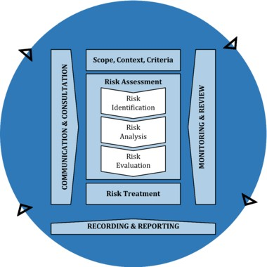
Figure 1: ISO 31000:2018 Risk Management Guidelines
The key steps in our risk assessment process were [Select from/add to the list below based on the risk assessment completed by the Shire/City/Town]:
- Preparing for the risk assessment by [insert only those items that were completed] gaining agreement on the purpose of the assessment, collating the data and information that we required, identifying the resources needed, and forming the project team and developing a schedule.
- Defining the scope, and developing an understanding of the external and internal context of the risk assessment. This included identifying our objectives and responsibilities, and reflecting on the demographic, socio-economic and environmental context in which we operate.
- Identifying the risks that we will be exposed to as a result of climatic changes, and the shift to a low carbon world.
- Evaluating the consequence and likelihood of each risk, and identifying the controls that we currently have in place to manage these risks.
- Following this process we combined the consequence and likelihood ratings to generate inherent risk scores, and then assessed how well our existing controls are managing these risks to determine the residual risk.
- We held a workshop with key internal stakeholders to validate our risks, agree on consequence and likelihood ratings, identify our existing controls for each risk ans their effectiveness, and determine residual risk ratings.
- Using the residual risk scores we were able to prioritise our risks and we have used this information to inform the setting of our actions.

Risks and Opportunities
Guidelines
Please update the listed indicative risks below to align with the risks most relevant to the local government. If the local government has completed a climate risk and/or opportunity assessment, then please update the below to reflect the results of this assessment rather than using the generic template. If possible, consider grouping the risks by their risk rating e.g. low risk, medium risk and high risk.
We recognise that climate change presents significant challenges, risks and opportunities to the Shire/City/Town of [insert].
Changes to our climate will present risks across many aspects of our Shire/City/Town including [Note: this is an indicative list only, and Local Governments should also include any other risks that they have identified through their risk assessment process that are not listed below]:
- Damage to, or loss of properties, building and infrastructure
- Reduced community liveability
- Damage to, or loss of biodiversity and natural habitat
- Increased heat, pest and water stress on vegetation
- Increased demand for water and electricity services
- Reduced public health or loss of life
- Reduced public safety and/or wellbeing
- Increased number of higher bushfire risk days, and severe bushfires
- Reduced public safety and/or wellbeing
- Damage to, or loss of biodiversity and natural habitat, as a result of coastal inundation and/or salt intrusion
- Damage to, or loss of coastal and low-lying buildings, infrastructure and land, as a result of coastal inundation
- Increased public displacement resulting from residents being forced to flee certain areas as a result of climatic changes
- Increased insurance premiums
- Increased maintenance of drainage and wastewater networks
- Decreased water quality
- Increased demand on emergency response and management services

While the risks of climate change have the potential to have severe impact on our Shire/City/Town, managing these risks also creates opportunities for the Shire/City/Town to improve the resilience of its community and operations. Effective adaptation to climate change will minimise disruptions and costs of climate change physical impacts and represent a good investment for the Local Government. Taking action to address climate change can also have positive social, environmental and economic impacts. For example, improving liveability, social inclusion, health and wellbeing, and our emergency preparedness, and supporting economic growth of the local economy.

Evaluation and Prioritisation of Adaptation Actions
Guidelines
The process for the evaluation, prioritisation and selection of actions is important for Local Governments to consider as part of their corporation adaption planning to ensure that selected actions are realistic and will contribute to achieving the greatest improvements in the resilience of our operations to climate change.
These criteria may include:
- Ability to manage climate risks
- Scale of investment needed
- Scale of cost per tonne of CO₂ equivalent abated
- Scale of potential emission reductions
- Ability to facilitate/leverage private sector or household investment
- Equity implications (benefits and costs to various stakeholders)
- Implications, if any, regarding climate change risks that various stakeholders might be exposed to as a consequence of the action
- Complexity
- Human resources available to implement the action
- Level of funding required
Local Governments should select from the above list but may also wish to include other criteria which are relevant to their operations and community to evaluate actions.
It is recommended that the Local Government assesses each of the action areas included in the WALGA Action Planning Excel Tool against their selected criteria, giving each a rating of low, medium or high. Examples have been provided in the indicative complexity and timeframe columns in the WALGA Action Planning Excel Tool, noting that these would form part of the broader criteria assessment process. Where more detailed information is available, Local Governments may use more detailed criteria for assessment, including quantitative assessment criteria.
The list provided within the WALGA Action Planning Excel Tool is an indicative list only from which Local Governments can select, and Local Governments will likely identify additional action areas to consider.

To select adaptation actions that will bring about the greatest improvements in the resilience of our operations to climate change, while being achievable for our Shire/City/Town, we assessed a long list of corporate adaptation actions against a number of criteria, which enabled us to identify those that will provide the greatest return on our investment.
The Local Government should then review the results of this evaluation process to identify those action areas which will be most effective to achieve adaptation outcomes, and to manage the identified climate change risks. Should the cost also be a factor for consideration, within the criteria, then this could also be used to inform the business case. Using the results of the evaluation process Local Governments should make an assessment as to whether to take the action area further, within the WALGA Action Planning Tool this is defined as:
- Proceed: Local Government has evaluated the action area and deemed it needs further consideration.
- Proceed – on hold: Local Government has evaluated the action area and deemed it needs further consideration. However, it will not be considered in the short term.
- Not proceed: Local Government has evaluated the action area and deemed it does not need further consideration.
- Underway: Action area is already in progress as part of existing Local Government actions.
At the completion of this process Local Governments will have a list of action areas, that will then be able to be converted into actions (refer to guidance for the Actions section below).
The following criteria were used as part of the assessment process [Note: a Local Government may choose not to include all criteria, in that case, only insert those that were used. Local Governments should also add any additional criteria if used to the list below]:
- Ability to manage climate risks
- Scale of investment needed
- Scale of cost per tonne of CO₂ equivalent abated
- Scale of potential emission reductions
- Ability to facilitate/leverage private sector or household investment
- Equity implications (benefits and costs to various stakeholders)
- Implications, if any, regarding climate change risks that various stakeholders might exposed to as a consequence of the action
- Complexity
- Human resources available to implement action
- Level of funding required
- Timeframe for implementation
Each action was assessed against the criteria and assigned a score of either Low, Medium or High [Note: Local Government to update the scoring criteria used for assessment, if they have not used low, medium, high]. Where it was identified that we have the resources available to execute a particular action, and that the action will result in our desired outcomes these were selected for inclusion in our Corporate Adaptation Action Plan.

Image: City of Joondalup (Source: WALGA)

Actions
Guidelines
The WALGA Action Planning Excel Tool provides Local Governments with a selection of action areas from which to choose through the evaluation and prioritisation process. For each action area that is selected, Local Governments must adjust the wording and convert the action area into an action, which reflects their current state and level of commitment.
The WALGA Action Planning Excel Tool supports this process. Local Governments should complete the ‘Results of evaluation and prioritisation process’ column, to indicate which action areas it has chosen to progress. Then for each of the areas that will be progressed the Local Government should consider its current state with regards to the implementation of the action area and select from the drop down list in the ‘Current status’ column as per the below guidance:
- Feasibility stage – During this stage a Local Government should conduct a detailed assessment of the feasibility of implementing activities in the adaptation area. For example this may include conducting a cost benefit analysis, and developing a business case. At the end of this action a Local Government will either decide to progress the action towards the following stage or determine that the action is not feasible to conduct, such as due to resourcing constraints or sub-optimal return on investment. Suggested wording for actions in this stage: Investigate the feasibility of…
- Planning stage – During this stage a Local Government has decided that it will progress an action and is at the stage of developing a plan for implementation. This action would include items such as developing a detailed project plan including tasks required to complete the actions, responsibilities, timelines and costs. During this stage Local Governments should also finalise funding for the action implementation. Suggested wording for actions in this stage: Develop a plan for the implementation of…
- Implementation stage – an action at this stage will involve implementing the project based on the project plan. Actions in this stage will also include those that have also commenced but require ongoing components. Suggested wording: Implement…
- Underway – an action at this stage is already in progress as part of existing Local Government actions. Suggested wording: Continue to…

Based on the action areas and their current status Local Governments will then be able to construct their list of actions.
Within the published Action Plan, Local Governments should include their identified actions, and may also consider including some, or all, of the aspects of their evaluation process. In addition, Local Governments may consider indicating the responsibility and targeted completion date for each action, which will improve accountability and assist with ongoing monitoring.
Local Governments may also select to include additional, more specific, information within their published action plan. For example, the estimated budget, monitoring indicators and project savings.
The Shire/City/Town of [insert] has identified the following corporate adaptation related actions:
[Populate table with actions from WALGA Action Planning Excel Tool and other selected information. Local Governments may also insert additional columns with further information.]

Category | Action | Responsibility (OPTIONAL) | Targeted completion date (OPTIONAL)

Communication
[Note: the inclusion of this section is optional]
Guidelines
Communication is an important component of climate change action planning to ensure that the Local Government is able to reach its desired audience to obtain support for its climate change adaption or mitigation planning, and to share its successes and challenges.
Local Governments may integrate communications relating to their climate action planning within existing communication programs, or determine that significantly new communication efforts are required.
Local Governments should consider both internal (i.e. within their operations) and external (i.e. outside of their operations) communication methods. Local Governments should ensure that communications do not discriminate and are accessible for the whole community.
It is important for our Shire/Town/City to communicate what we are doing in relation to climate change adaptation to our employees and community to obtain support for our actions, and to share our successes and challenges.
[Note: the following statement is optional] We have integrated aspects relating to our corporate adaptation action planning within our [insert name of existing communications strategy/plan]
Our climate action planning communication strategy comprises both internal and external aspects.
Internally we will: [Select from/add to the list below]
- Share resources on our adaptation actions via our intranet
- Provide [insert frequency of updates] updates at Councils/staff meetings
- Include communications within internal newsletters
- Establish an internal working group
Externally we will: [Select from/add to the list below]
- Communicate what we are doing through our website
- Share good news stories in our local newspaper
- Include communications within external newsletters/mail outs
- Establish an external working group

Monitoring and Evaluation
Guidelines
The monitoring and evaluation of climate change action planning can be challenging, as the time frames associated with climate change and the associated adaptation and mitigation outcomes are typically longer than those of traditional monitoring programs. In addition, there is uncertainty associated with the magnitude and nature of climate change at the local level, which can influence monitoring results and the way they are evaluated.
It is recommended that Local Governments adopt an adaptive management approach to climate change action monitoring and evaluation. Adaptive approaches will allow Local Governments to continue to iterate and adjust their Action Plans over time as progress towards targets as action is made, to enable the Plans to stay relevant, and to remain in line with latest climate science and best practice Local Government climate change management.
Local Governments are encouraged to establish a monitoring and evaluation framework that seeks to assess the outcomes or effectiveness of the Actions taken through the use of monitoring indicators, rather than only assessing the outputs, hence these can be used whether actions have or have not yet been completed. During the development of the Action Plan/s the Local Government should select clear and measurable indicators to monitor the performance of each action. These indicators will help to:
- Evaluate and track performance
- Assist with the identification of when new adaptation actions should be undertaken
- Determine whether planned outcomes have been achieved
Where possible, Local Governments should seek to align/embed the climate change Action Plan monitoring and review process within existing monitoring and review procedures/protocols. The template text has been provided as a guide and should be updated to align with existing processes where relevant.
For example, if the Local Government has existing standards/protocols for determining the frequency of document reviews these should be referenced within this section (e.g. “This Action Plan will be reviewed on an annual basis in line with the City’s Risk Management Framework”).

Local Governments should refer to CoastAdapt’s guide to monitoring and evaluation in climate change adaptation when developing their monitoring program. While this guide is specific to climate change adaption, the concepts are also applicable to mitigation actions. The key points from this guide are:
- Local Governments should select clear and measurable indicators to monitor the performance of each action.
- A monitoring and evaluation program, should be designed so that it is linked to decision making. This step will include identifying how each indicator will be assessed, what data is required, the frequency at which each indicator will be assessed, how the outputs of the monitoring and evaluation process will be communicated, and who is responsible for monitoring and evaluation.
- Evaluation needs to track actions that are being undertaken and providing feedback to relevant stakeholders on the success of actions, as well as any adjustments may be required. Evaluation should also include a broader review of the whole action plan, and whether its objectives are being achieved.
- Communicating the results of monitoring and evaluation with key stakeholders is also an important components of building support. Results need to be communication in a clear way. Items to consider include using a similar scale to report across all indicators, using a 2 or 4 point scale (e.g. ‘very good’, ‘good’, ‘poor’, ‘very poor’), developing a scale system to report on progress towards targets (‘target met’, ‘target not met’), and using colours to provide a simple grading schema.
Indicators
When setting indicators Local Governments should refer to CoastAdapt’s guidance on identifying indicators for monitoring and evaluation. Indicators should be:
- Specific – indicators should capture the essence of the desired result by clearly and directly relating to the achievement of an objective and only that objective.
- Measurable – indicators must be measurable, with consideration given to the repeatability of assessment, the precision required for measurement, and the resources (funding, time) needed for measurement.
- Achievable and attributable – the monitoring and evaluation system, and related indicators, identify what changes are anticipated as a result of the intervention and whether the results are realistic. Attribution requires that changes in the targeted developmental issue can be linked to the intervention.
- Relevant and realistic – the monitoring and evaluation system and related indicators establish levels of performance that are likely to be achieved in a practical manner and that reflect the expectations of stakeholders.

- Timely – indicators need to be time sensitive to change. For example, some variables are slow changing and highly variable across years (e.g. climate), meaning that progress towards outcomes can be difficult to assess over the short term. In these situations, it is helpful to identify intermediate outcomes that lead towards longer-term outcomes.
- Time-bound, timely, trackable, and targeted – the monitoring and evaluation system and related indicators allow progress to be tracked in a cost-effective manner at the desired frequency for a set period, with clear identification of the particular stakeholder group(s) to be affected by the project or program.
Examples of indicators include:
Indicator example | Matched measure example | Explanation
Extent of vulnerability of coastal infrastructure | Percentage of most vulnerable infrastructure upgraded to meet existing and forecast challenges | Quantitative data; categories could also be used, for example: all, most, some, none.
Changes in impacts associated with storm surge | Changes in frequency, intensity and location of storm surge events after adaptation activities have been undertaken | Quantitative geo-referenced data, collected over a one year timeframe post action (matches challenge data).
Local Governments may choose to include their monitoring indicators for each action as part of the action plan.
During the monitoring stage, Local Governments should review each pre-determined indicator using the most appropriate data at its selected monitoring frequency. It is important for Local Governments to understand that some data may be publicly available, whereas, other more detailed data points will likely require measurement by the Local Government, which must be considered as part of program resourcing.
If the Local Government has conducted a climate change risk assessment the review process for this should also be referenced within this section and where relevant include reference to existing procedures (e.g. “Our climate change risk assessment will be reviewed on an annual basis in line with the City’s Risk Management Framework, and changes to our risks will be reflected within our Action Plan/s.”).

Having a formal, periodic process in place for monitoring and evaluating our Action Plan/s is fundamental to understanding our progress in addressing climate change, and the effectiveness of our actions, and will assist us in guiding future decisions. Monitoring and evaluation of our Action Plan/s will also generate learning and idea creation opportunities in relation to climate change which will help to improve the design and delivery of future climate change related policies, plans and activities. It is our aim that, through this ongoing monitoring and evaluation process, we will embed climate change adaptation considerations into our business as usual processes.
We will use indicators to understand how we are tracking in relation to implementing our adaptation actions. For each action we have identified indicators that we can measure to track performance and understand whether the desired outcomes are being achieved.
This Action Plan/s will be monitored on an [insert frequency of review e.g. annual, biannual] basis.
The outcomes of the assessments will be used to identify key challenges and focus areas for the following year based on actions that are not on track for completion within their timeframe, and actions that have not resulted in the achievement of the intended adaptation outcomes.
Following the annual monitoring process, we will evaluate our Action Plan/s and identify whether any areas require updates, or additional funding/focus in order to be achieved. Any changes made will be communicated through the Councils and to our community where relevant.
We will also update our climate change risk assessment every X years to enable us to track our progress in managing risks. As adaptation actions are implemented to address the risks resulting from climate change, the residual risks will reduce, which will demonstrate progress in our approach to adaptation. However, should our adaptation actions not be undertaken, the residual risks will remain the same, and will demonstrate lower levels of progress against our plan.
Our Action Plan/s will be reviewed in full every X years to maintain its relevance and currency. This will be a wider review process including input from [insert names of relevant internal teams and external stakeholders that will be involved in the full review process].

Reporting
The outputs of the [insert frequency of review e.g. annual, biannual] review process will be documented in a report to Councils showing progress against each action and target. Where changes are required to Action Plan/s as a result of the annual report these will be submitted to Councils for approval.
The outcomes of the full review process will generate a revised version of the Action Plan which will be submitted to Councils for approval before being adopted.
Major updates and achievements will be publicly communicated to our residents, businesses, and the wider community such as through online communications, and within our Annual Report [insert titles of other Local Government documents where information will be reported].

Glossary

Climate
The composite of surface weather conditions such as temperature, rainfall, atmospheric pressure, humidity, sunshine and winds, averaged over a period of time ranging from months to thousands of years.

Climate change
Any change in climate over time, whether due to natural variability or as a result of human activity.

Climate change mitigation
Climate change mitigation consists of actions to limit the magnitude or rate of long-term climate change. Climate change mitigation generally involves reductions in human emissions of greenhouse gases.

Climate change adaptation
Climate change adaptation is a response to global warming and climate change, that seeks to reduce the vulnerability of social and biological systems to relatively sudden change and thus offset the effects of global warming.

Adaptive capacity
The capacity of an organisation or system to moderate the risks of climate change, or to realise benefits, through changes in its characteristics or behaviour.

Climate projection
A projection of the response of the climate system to scenarios of greenhouse gas emissions or atmospheric concentrations of greenhouse gases. Climate projections are often based upon simulations of the climate system by computer based mathematical models. Climate projections depend on assumptions about emission rates and concentrations and response of the climate system to changes in these variables and can therefore be distinguished from climate predictions.

Climate scenario
A coherent, plausible but often simplified description of a possible future state of the climate. A climate scenario should not be viewed as a prediction of the future climate. Rather, it provides a means of understanding the potential impacts of climate change, and identifying the potential risks and opportunities created by an uncertain future climate.

Climate variability
Variations or deviations from the mean state of the climate. The climate system has natural, internal variability but variability could be affected by external factors driving climate change such as changes in the atmospheric concentration of greenhouse gases.

Enhanced greenhouse effect
Increases in the atmospheric concentration of greenhouse gases such as carbon dioxide, methane and nitrous oxide due to human activities, leading to an increase in the amount of thermal radiation near the Earth’s surface.

Extreme event
Weather conditions that are rare for a particular place and/or time such as an intense storm or heat wave.

Global warming
An increase in the global average surface temperature due to natural or human caused factors.

Greenhouse gases
A greenhouse gas (GHG) is a gas in an atmosphere that absorbs and emits radiation within the thermal infrared range. This process is the fundamental cause of the greenhouse effect.

Greenhouse effect
The process where gases in the lower atmosphere such as carbon dioxide and water vapour trap radiation released by the Earth’s surface after it has been warmed by solar energy. These gases then radiate heat back towards the ground, adding to the heat the ground receives from the Sun.

Net zero emissions
Carbon neutrality, or having a net zero carbon footprint, refers to achieving net zero carbon emissions by balancing a measured amount of carbon released with an equivalent amount sequestered or offset, or buying enough carbon credits to make up the difference.

Offsets
A carbon offset (or carbon credit) is generated from an activity that prevents, reduces or removes greenhouse gas emissions from being released into the atmosphere to compensate for emissions occurring elsewhere.

Renewable energy
Renewable energy is energy that is collected from renewable resources that are naturally replenished on a human timescale, such as sunlight, wind, rain, tides, waves, and geothermal heat.

Resilience
The capacity of individuals, institutions, businesses and systems to adapt to chronic stresses and acute shocks.

Sensitivity
The degree to which a system is affected, either adversely or beneficially, by climate related variables including means, extremes and variability.

Urban heat island effect
Refers to when an urban area is significantly warmer than its surrounding rural areas due to human activities. The main cause of the urban heat island effect is from the modification of land surfaces.

Vulnerability
The extent to which a system or organisation can cope with the negative impacts of climate change, variability and extremes. It is a function of risk and adaptive capacity.

